Installation Guide

# Pre-requisite

The web applications are developed using the following technologies. Please make sure the following tools & framework has been installed into your PC.

1. Visual Studio 2017
2. SQL Management Studio 14.0 & above
3. SQL Server 2014 & above
4. .Net Framework 4.6.1

# Database Setup

Please follow the steps below to perform database setup

1. Navigate to “DatabaseDeployment” folder on the root of the project.
2. Execute script “001 – Init Database and two test users.sql” using SQL Management Studio.

Once the script has ran, there should be one database named “SiteCoreTest” created in your local server.

Make sure your local pc database server is using server name “localhost” instance. If your local database server name is not “localhost”, you may need to change the connection string configuration under “web.config” file for both “SingleSignOn” and “SampleHost” project

# How to Run the Web Application

Please follow the step below:

1. Open Visual Studio. Make sure you ran Visual Studio in Administrator mode.
2. From Visual Studio, open the “SingleSignOn.sln” file under “SingleSignOn” folder on the root of the project.

To run the “SingleSignOn” project and “SampleHost” project, just simply right click on both projects within Visual Studio Solution Explorer and click on “Debug > Start New Instance” .

Please take note that the “SingleSignOn” project must be executed first before running the “SampleHost” as it has Web Api dependency to “SingleSignOn” projects.

Please also ensure the following ports and database setups are correct for “SingleSignOn” and “SampleHost” projects.

1. After you ran “SingleSignOn” project, the web service should open a browser showing url with port 51393. If the port number is not correct, please change the port number under the project properties “Web” section. Please refer to the below photo.  
   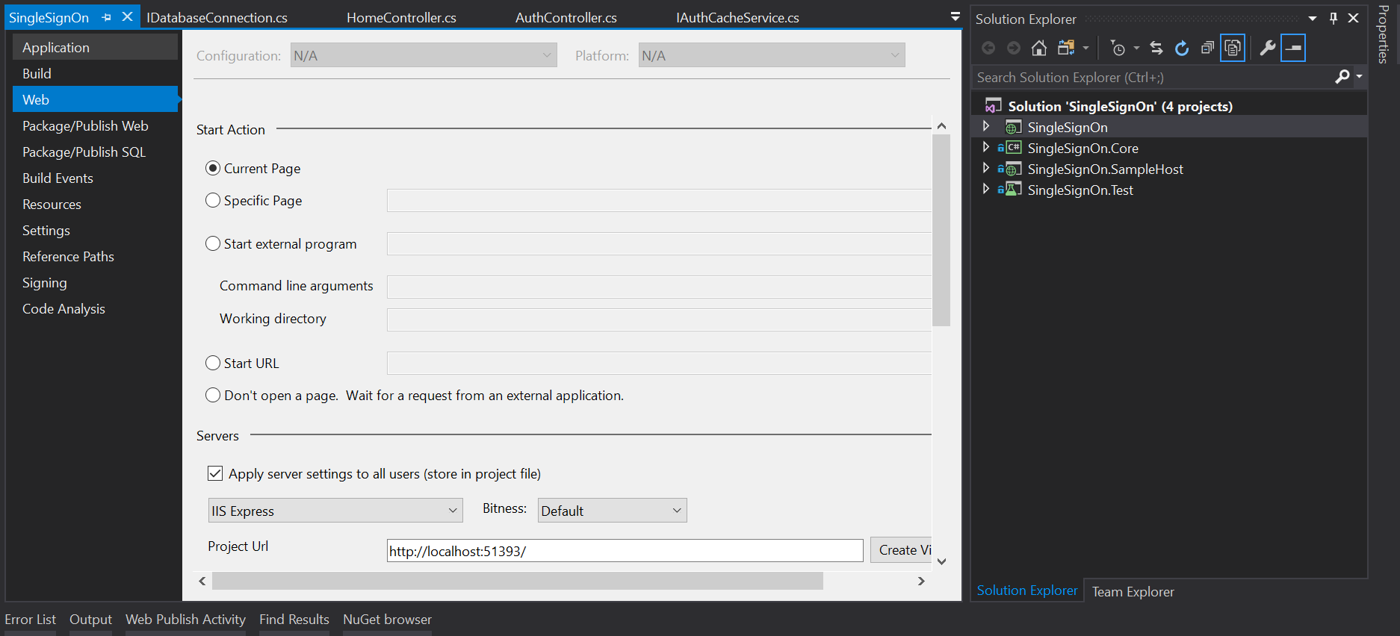
2. Make sure the connection string is correct for the two projects. If you having different server name other than “localhost”, then you may have to alter the connection string in order to run the project.